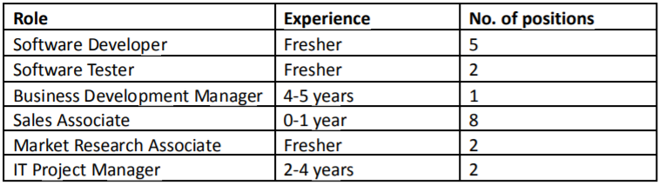

What will be your strategy to close these positions in given timelines? What will be sources of recruitment that you will use for Junior roles and experienced roles?

Answer. We need to implement different strategies to overcome the barriers and challenges we may have during the hiring process.

A strong brand positioning in the market will also attract the candidates faster.

**Hiring Freshers:**

Virtual meet up with the candidate and they can apply for the job through a link

Placement officer

Universities/Colleges

**Hiring Plan:**

Job Portals (Paid/Free)

Vendors/Colleges/Direct Sourcing

Email Blast/Job Postings/ATS

Attractive benefits/Programs

Database/Referrals

Good to have tie up with good universities /colleges. From my experience, careers fairs have helped a lot in hiring fresh graduates. I have done campus placements earlier and currently does Virtual career fairs due to pandemic situation.

We can get in touch with the placement officers/coordinators and give them the list of requirements we are hiring along with company profile. They will float it to all department heads, notice boards, Alumni page, publish in career pages etc.

If we can target IT/CS bachelors /Master degree holders from good universities, we can close 10 roles stated above.

*Email and Job Advertisements- (For Freshers)*

Sourcing via Local job portals, email blast, job postings, run through current database, referrals.

**Hiring Juniors/Freshers (10 HC)**

When it come to hiring juniors, we may have to spend time in sourcing, job postings depending on the skillsets.

Industry/ Domain based search also can help based on our clientele.

Target our competitors and understand their hiring practices/process and then do postings /Ads which is more attractive compared to our competitors

Attractive Job postings (Mention benefits /Referral Bonus for each candidate they refer etc). This can help to get more applications.

If we have an ATS tool, its easy to reach out to our existing data base, post jobs and mass mailing.

**Hiring Experienced (1 HC)**

* Understand the requirement and skillsets needed
* Know more about the client domain and projects
* Target people working in similar domain/Industry first
* Reach out to our existing employees for referrals
* Sourcing/Email/Advertisements

If I have a team to help, then I will split these requirements based on their expertise on specific skillsets to keep a fair and fast hiring practices. I will guide them, mentor them and will also contribute my knowledge to my team and I’m always open to new ideas, suggestions and discussions.

**Vendor management:**

I currently handle 10-12 vendors/ external agencies for my volume hiring. The advantage is that we will have more bandwidth to source and get profiles and close it within the deadline. But we may have to share a percentage of our profit/margin. So, it really depends on the need and how urgent is the project deadline.

2. If you have received approximately 100 applications for each role, how will you screen the resumes quickly?

**For freshers:**

* Segregate based on their stream (Eg: IT/ Comp Science/Mechanical etc)
* Segregate based on Top 10 Universities/Colleges.
* Talk to those candidates – Check their communication skills, attitude, their pipeline (other interviews/offers), interest level, email acknowledgements, etc
* Shortlist them and arrange a client interview.
* Next stage is Selection- Offer- Negotiation- HR – Onboarding formalities.

**For Experienced:**

* Segregate based on top 10-12 skillsets as per the requirement
* Segregate again based on mandatory skillsets
* Check similar industry/domain experience
* Talk to those candidates – Check their communication skills, attitude, their pipeline (other interviews/offers), interest level, get email acknowledgements, etc

Shortlist the 80-90% match profiles first and followed by 60-70%

3. If you do not have sufficient pipeline for any role, how will you build the pipeline or increase the existing candidate pool?

I would sit with the team first to understand the barriers and analyse the bottlenecks.

* Need to check if the skillsets are niche or generic, compensation is as per mkt standards, benefits, client domain, etc.
* Firstly, I should evaluate the challenges so that I can come up with a proper solution and strategy.
* I can try different methods to increase the pipeline or pool but it has to be cost effective and not much time consuming.
* Try out all the free job postings, Forums, social networking sites to increase the reach to the candidates.
* Try to get more info from the client regarding the role and skillsets. Sometime an alternate skillset may also help which can help us to find more profiles.

I hope I have answered all the questions with some details. Kindly let me know if any clarification or queries.